Skew Lines in Solid Geometry
# Source: AI Source: Provided by: [Data Path: Persons Table -> ID Column: 1, Name_En Column: Motasem Essam] -> From: [ChatGPT] on [7/25/2026]
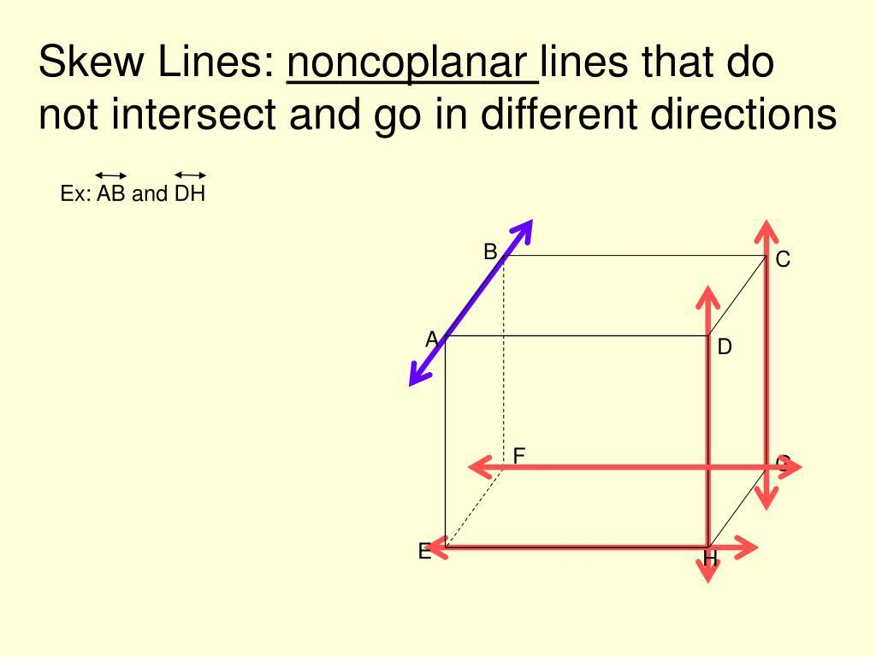
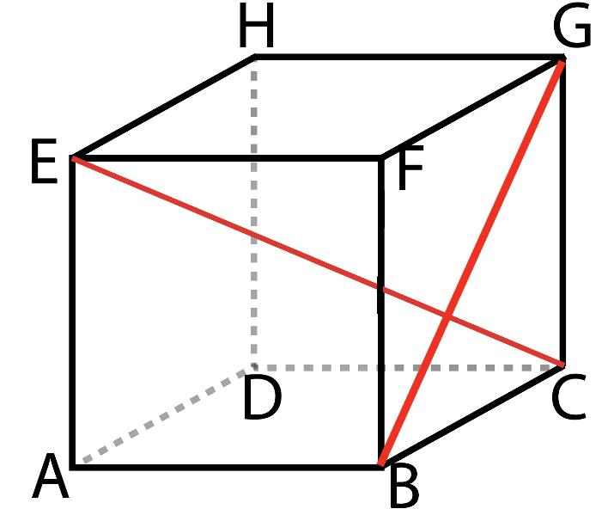
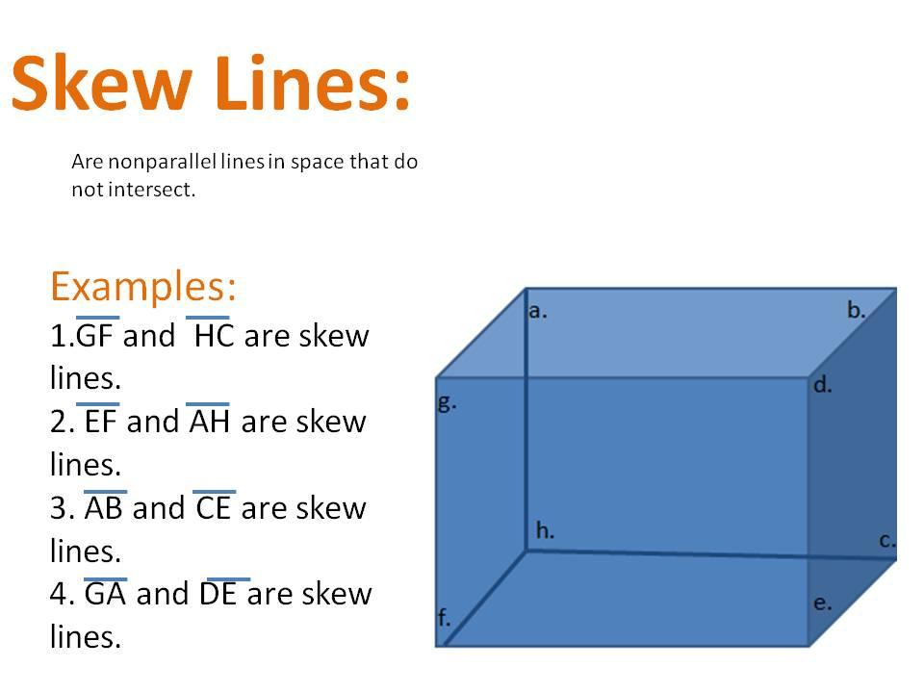

Definition
# Source: AI Source: Provided by: [Data Path: Persons Table -> ID Column: 1, Name_En Column: Motasem Essam] -> From: [ChatGPT] on [7/25/2026]
Skew lines are two distinct straight lines in three-dimensional space that do not intersect and are not parallel. They lie in different planes, meaning that no single plane contains both lines.
Unlike intersecting lines, skew lines have no common point. Unlike parallel lines, they do not have the same direction.
Skew lines are possible in solid geometry (three-dimensional geometry) but not in ordinary two-dimensional Euclidean geometry, because two non-parallel lines in the same plane must intersect.

Simple Definition
# Source: AI Source: Provided by: [Data Path: Persons Table -> ID Column: 1, Name_En Column: Motasem Essam] -> From: [ChatGPT] on [7/25/2026]
Two lines are skew if they:
- Do not meet at any point.
- Are not parallel.
- Do not lie in the same plane.
For example, two carefully selected edges of a cube can be skew lines if they belong to different directions and do not share a vertex.

Key Characteristics of Skew Lines
# Source: AI Source: Provided by: [Data Path: Persons Table -> ID Column: 1, Name_En Column: Motasem Essam] -> From: [ChatGPT] on [7/25/2026]
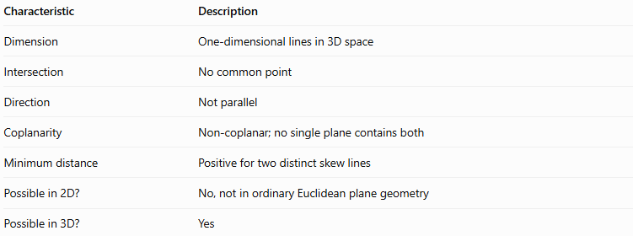
Characteristic | Description
Dimension | One-dimensional lines in 3D space
Intersection | No common point
Direction | Not parallel
Coplanarity | Non-coplanar; no single plane contains both
Minimum distance | Positive for two distinct skew lines
Possible in 2D? | No, not in ordinary Euclidean plane geometry
Possible in 3D? | Yes

Examples of Skew Lines

A. Skew edges of a cube
# Source: AI Source: Provided by: [Data Path: Persons Table -> ID Column: 1, Name_En Column: Motasem Essam] -> From: [ChatGPT] on [7/25/2026]
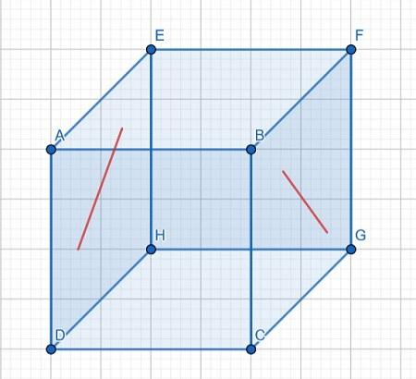
Consider a cube labeled $ABCD$ on its bottom face and $EFGH$ on its top face, with vertical edges joining corresponding vertices.
The bottom edge $AB$ and a suitable vertical edge such as $CG$ are skew if they neither share a vertex nor run in parallel directions.
They do not intersect, they are not parallel, and they do not lie in the same plane.

B. Edges of a rectangular prism
# Source: AI Source: Provided by: [Data Path: Persons Table -> ID Column: 1, Name_En Column: Motasem Essam] -> From: [ChatGPT] on [7/25/2026]
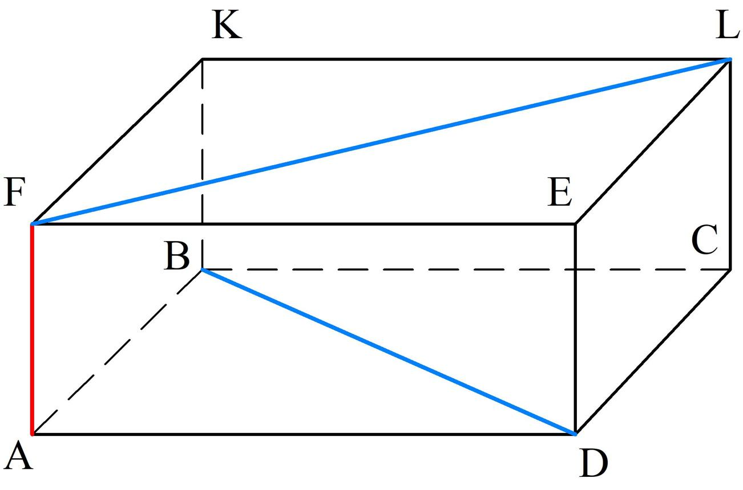
A rectangular prism provides many examples of skew lines. For instance, an edge running from front to back and a vertical edge on the opposite side may be skew if they do not meet and are not parallel.

C. Real-world examples
# Source: AI Source: Provided by: [Data Path: Persons Table -> ID Column: 1, Name_En Column: Motasem Essam] -> From: [ChatGPT] on [7/25/2026]
- A horizontal edge on the front of a rectangular box and a vertical edge at the rear, selected so that they do not share a vertex.
- Two non-parallel straight structural bars positioned at different depths.
- The straight line representing one direction of a three-dimensional framework and another line crossing its direction at a different height, without intersecting.
These examples are geometric models; real objects may have thickness, whereas mathematical lines have no thickness.

Mathematical Representation of Skew Lines
# Source: AI Source: Provided by: [Data Path: Persons Table -> ID Column: 1, Name_En Column: Motasem Essam] -> From: [ChatGPT] on [7/25/2026]
In three-dimensional space, two lines can be represented using vector equations:
$$L_{1}: r=a+tu$$
$$L_{2}: r=b+sv$$
where:
- $a$ and $b$ are position vectors of points on the lines.
- $u$ and $v$ are their direction vectors.
- $t$ and $s$ are real parameters.
For the lines to be skew, they must satisfy two conditions:
1. Their direction vectors are not parallel:
$$u×v≠0$$
2. The lines are not coplanar:
$$\left(b-a\right)⋅\left(u×v\right)≠0$$
The second expression is the scalar triple product. A nonzero result proves that the lines are non-coplanar and therefore skew.
Minimum distance between skew lines
The shortest distance between two skew lines is the length of their common perpendicular segment.
$$\boxed{d=\frac{\left|\left(b-a\right)⋅\left(u×v\right)\right|}{\left|u×v\right|}}$$
This formula applies when the direction vectors are not parallel.

How to Determine Whether Two Lines Are Skew
# Source: AI Source: Provided by: [Data Path: Persons Table -> ID Column: 1, Name_En Column: Motasem Essam] -> From: [ChatGPT] on [7/25/2026]
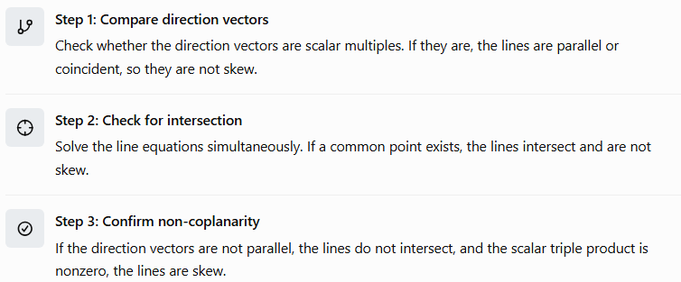
Step 1: Compare direction vectors
Check whether the direction vectors are scalar multiples. If they are, the lines are parallel or coincident, so they are not skew.
Step 2: Check for intersection
Solve the line equations simultaneously. If a common point exists, the lines intersect and are not skew.
Step 3: Confirm non-coplanarity
If the direction vectors are not parallel, the lines do not intersect, and the scalar triple product is nonzero, the lines are skew.

Worked Mathematical Examples
# Source: AI Source: Provided by: [Data Path: Persons Table -> ID Column: 1, Name_En Column: Motasem Essam] -> From: [ChatGPT] on [7/25/2026]
Example 1: Identifying skew lines
Consider the lines
$$L_{1}:\left(x,y,z\right)=\left(0,0,0\right)+t\left(1,0,0\right)$$
$$L_{2}:\left(x,y,z\right)=\left(0,1,1\right)+s\left(0,1,0\right)$$
Their direction vectors are
$$u=\left(1,0,0\right), v=\left(0,1,0\right)$$
They are not parallel because their direction vectors are not scalar multiples.
The first line has $y=0,z=0$. The second has $x=0,z=1$. They cannot intersect because their $z$-coordinates are always different.
Now calculate the scalar triple product:
$$u×v=\left(0,0,1\right)$$
$$b-a=\left(0,1,1\right)$$
$$\left(b-a\right)⋅\left(u×v\right)=1$$
Since the result is nonzero, the lines are non-coplanar.
Conclusion: The lines are skew.
Example 2: Calculating the shortest distance
Using the same lines:
$$d=\frac{\left|\left(0,1,1\right)⋅\left(0,0,1\right)\right|}{\left|\left(0,0,1\right)\right|}$$
$$d=\frac{\left|1\right|}{1}$$
$$\boxed{d=1}$$
The minimum distance between the two skew lines is one unit.
Example 3: Distinguishing skew from parallel lines
Consider
$$L_{1}:\left(x,y,z\right)=\left(0,0,0\right)+t\left(1,0,0\right)$$
$$L_{2}:\left(x,y,z\right)=\left(0,2,0\right)+s\left(1,0,0\right)$$
Both direction vectors are $\left(1,0,0\right)$, so the lines are parallel. They do not intersect, but they are coplanar.
Conclusion: These are parallel lines, not skew lines.

Comparison with Other Types of Lines
# Source: AI Source: Provided by: [Data Path: Persons Table -> ID Column: 1, Name_En Column: Motasem Essam] -> From: [ChatGPT] on [7/25/2026]
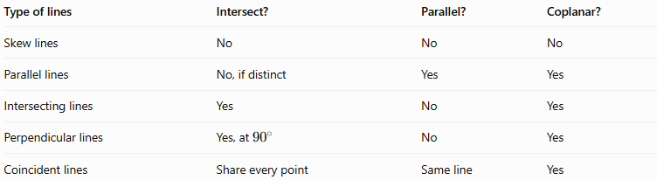
Type of lines | Intersect? | Parallel? | Coplanar?
Skew lines | No | No | No
Parallel lines | No, if distinct | Yes | Yes
Intersecting lines | Yes | No | Yes
Perpendicular lines | Yes, at ${90}^{∘}$ | No | Yes
Coincident lines | Share every point | Same line | Yes
Important distinction: Two lines that do not intersect are not automatically skew. They may be parallel. Non-coplanarity is the defining feature that separates skew lines from parallel lines.

Applications of Skew Lines
# Source: AI Source: Provided by: [Data Path: Persons Table -> ID Column: 1, Name_En Column: Motasem Essam] -> From: [ChatGPT] on [7/25/2026]
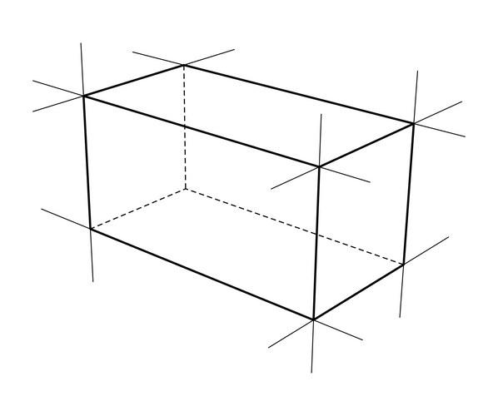
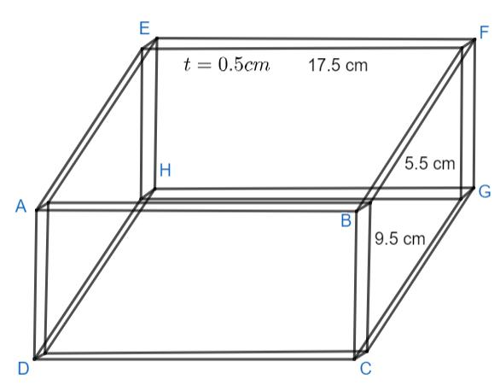
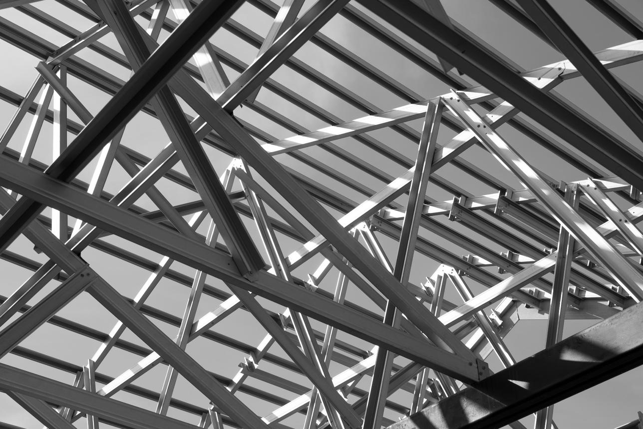
Skew lines are useful in:
- Architecture: Understanding the spatial relationships between structural members.
- Engineering: Analyzing the positions of rods, supports, and components in three-dimensional assemblies.
- Computer graphics: Determining depth and spatial relationships between objects.
- Robotics: Calculating distances between non-intersecting paths or axes.
- Technical drawing: Representing three-dimensional objects accurately in two-dimensional views.

Key Points
# Source: AI Source: Provided by: [Data Path: Persons Table -> ID Column: 1, Name_En Column: Motasem Essam] -> From: [ChatGPT] on [7/25/2026]
- Skew lines exist only in three-dimensional or higher-dimensional settings, not in ordinary two-dimensional Euclidean geometry.
- They never intersect.
- They are not parallel.
- They are non-coplanar.
- Their shortest distance is positive.
- The scalar triple product can be used to test non-coplanarity.
- A pair of non-intersecting lines is skew only if the lines are also non-parallel.

Conclusion
# Source: AI Source: Provided by: [Data Path: Persons Table -> ID Column: 1, Name_En Column: Motasem Essam] -> From: [ChatGPT] on [7/25/2026]
Skew lines are a distinctive type of line relationship in solid geometry. They occupy different planes, never intersect, and do not share the same direction. Recognizing skew lines helps distinguish spatial relationships that cannot occur in ordinary plane geometry. Their properties are especially useful in three-dimensional visualization, geometric proofs, engineering, and distance calculations.

